THE VICTORIAN BACK BAY TOUR

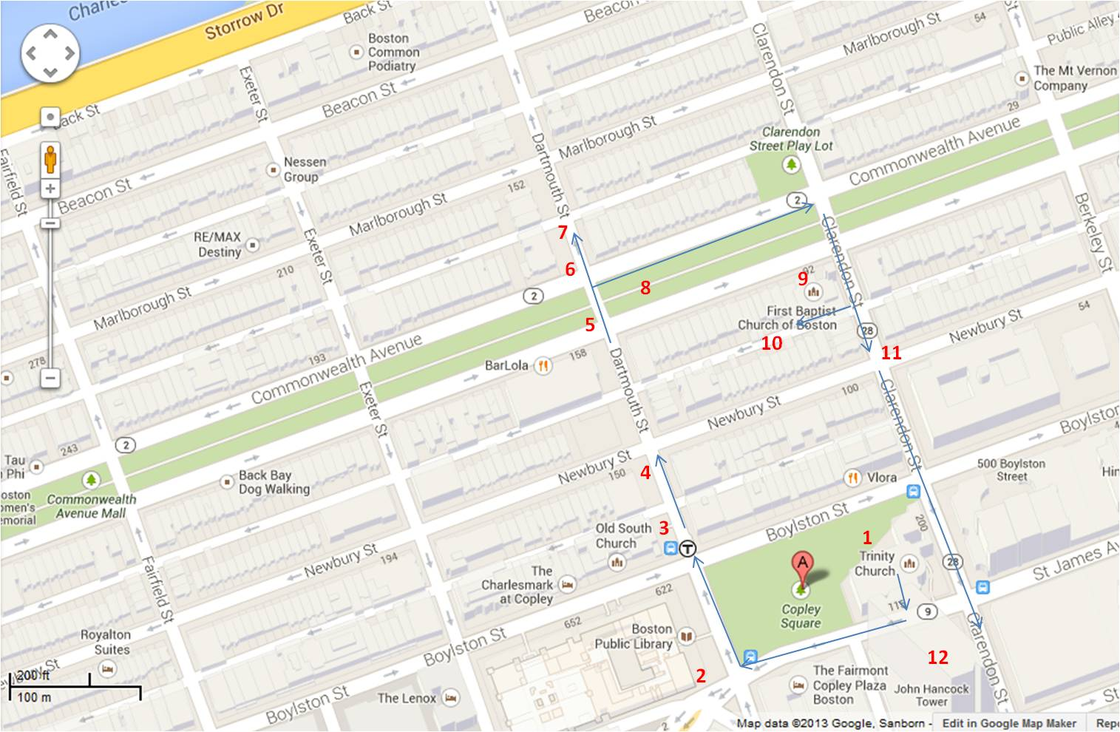
TOUR MAP

INTRODUCTION

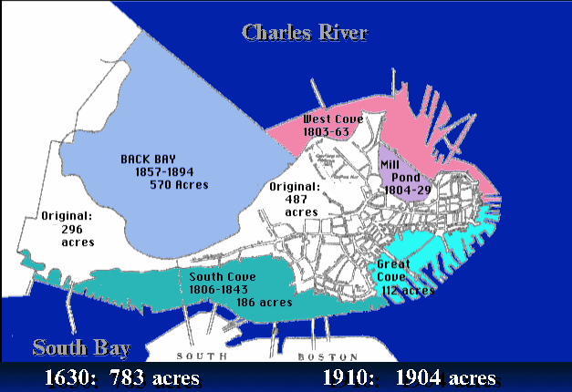
INTRODUCTION – Stand in front of the Trinity Church steps

Hello. My name is Aline Kaplan and I’m a docent for Boston by Foot. We’re a volunteer organization that gives history and architecture tours of Boston. Boston by Foot has been offering tours since 1976 because Boston is a great walking city where you can see more details on foot than you can by driving around.

Where are you all from? How have you heard of the Back Bay?

Today we’re going to be walking on water, through history and over the largest hidden forest in the world. We’re going to see some wonderful examples of buildings erected in the nineteenth and twentieth centuries, and hear stories of how and why they were built—along with the problems some of them encountered.

The area commonly referred to as Back Bay today extends from Arlington Street to Massachusetts Avenue and from the Charles River to Boylston Street. However, the Back Bay in the 18th century was 737.5 acres of tidal flats with navigable creeks that extended as far west as Kenmore Square and as far south as Washington Street, including part of the South End, part of Bay Village and the Public Garden.

The Back Bay has been called the most outstanding achievement in 19th-century American Urban Planning because filling in this region of shallow salt marshes and mud flats was an enormous technological feat.

Population, pollution and Protestants

In the early nineteenth century, Uriah Cotting formed the Boston and Roxbury Mill Corporation, and in 1814 proposed a Mill Dam—an extension of Beacon Street that went all the way to Brookline. The Back Bay was intersected by a cross dam on which several mills were situated to utilize the change in tides affecting the Charles River, a tidal estuary. Although the Mill Dam, completed in 1821, was not a financial success, it did reduce tidal flow in the basin. The resulting stagnation was made worse when Boston allowed sewage to be discharged here in 1827.

Two railroad causeways were built across the Bay several years later, after which the area became very smelly. In 1849, the Health Department declared that the Bay was a great cesspool, a hazard to the general health, and demanded that it be filled.

Population, Pollution and Protestants

In addition there was pressure to find more buildable land because the available land on the peninsula had already been developed. This left no room for a new elegant neighborhood that was within walking distance of Boston’s commercial district. The combination of these pressures caused the parties involved to resolve their differences.

Ultimately a Tripartite Indenture achieved a settlement between the Commonwealth of Massachusetts, the City of Boston, and the Boston Water Power Company. It was signed on December 11, 1856, enabling the filling of Back Bay to begin.

The project of filling the Back Bay would have been impossible without the invention of the steam shovel and the steam locomotive engine. A railroad was built from the gravel pits of Needham (9 miles west) to the Back Bay. A steam shovel loaded the cars, and the trains (sometimes up to 35 cars each) arrived in Back Bay every 45 minutes, approximately 24 hours a day, 6–7 days a week. The actual area filled was much larger than the residential locale known as the Back Bay today—but for our purposes the area we will discuss is bordered by Arlington Street, Boylston Street, Massachusetts Avenue, and the Charles River.

The north-to-south cross streets were given English names in alphabetical order: Arlington, Berkeley, Clarendon, Dartmouth, Exeter, Fairfield, Gloucester, and Hereford.
The state’s land (which is what we think of as the Back Bay today) was in a most desirable location: close to Boston’s financial and shopping areas, close to the Charles River, and with restrictions that made it attractive to the upper middle class whom the state wanted to attract.

Most of the eastern part of Back Bay was filled by the state and the BWP, which had operated the mills. The state’s filling began in May 1858, proceeding east to west from the Public Garden to a jagged line between Exeter and Fairfield that marked the end of its territory; it finished filling its 100 acres by 1876. The BWP completed its 300 acres east of Massachusetts Avenue in the late 1880s. (The BWP did more filling in the Fenway area in the 1880s and 90s.)

COPLEY SQUARE – Stand in front of Trinity Church

COPLEY SQUARE is bounded by Boylston Street, Clarendon Street, St. James Avenue, and Dartmouth Street. It was first called “Art Square” because the original Museum of Fine Arts building rose on the site where the Fairmount Copley Plaza Hotel now stands. This was an ornate structure that introduced large-scale exterior terra cotta work to America. MIT’s first edifice, Rogers Hall (1865) was located where the former New England building now stands until that institution moved to Cambridge in 1916.

A triangular lot bounded by Huntington, Dartmouth, and Boylston was purchased by the City in 1883 and the name was changed to Copley Square in honor of Boston-born artist John
Singleton Copley, who was America’s first great portrait painter. (The bronze statue of Copley, designed by Lewis Cohen, was dedicated in October 2002.)

The following year, a triangular lot bounded by Huntington, Trinity Place, and St. James was added to the Square, forming two triangles intersected by Huntington Avenue. In 1965, the Huntington Avenue traverse was removed, which eliminated vehicular traffic through the Square.

Art Square

Purportedly, it was said that Trinity Church represented the spirit, the Museum of Fine Arts the senses, and the Boston Public Library the mind. Thus, the Square was thought to contain everything a cultured, well-rounded Bostonian might need.

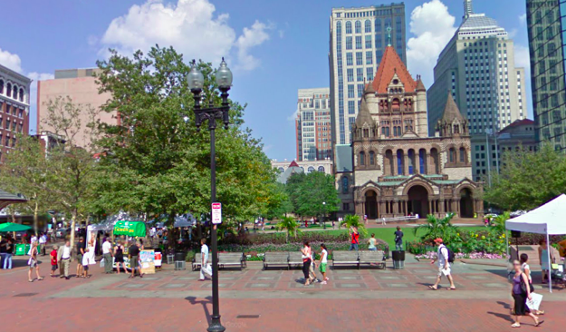
Most buildings in the Back Bay are built on wooden pilings – an estimated 1.5 to 2 million trees in total. This is the largest hidden forest in the world.
- TRINITY CHURCH: Stand in front of the church

- Trinity Church: H.H. Richardson 1872–77 (5 Years)
- Renovation/expansion: Goody, Clancy & Associates 2002–07

This was the third structure built for the Trinity congregation, which moved here from downtown. The popular and charismatic rector, Phillips Brooks (1835–1893), led the movement to relocate in Back Bay before its earlier church burned in the fire of 1872. He was involved in the planning of the new church from the start and held a design competition. Brooks’ Harvard friend, H.H. Richardson, was selected as the architect.

Henry Hobson Richardson (1838–1886), born in New Orleans, was 34 years old at the time of this commission. He had graduated from Harvard and studied at the École des Beaux-Arts in Paris before beginning his architectural career.

Considered the masterpiece of Richardson’s short career (he was only 33), the church draws its inspiration from the French Romanesque style, especially the Auvergne region in southwest France. The triple doorway, now hidden by the western porch, is modeled on that of St. Gilles-du-Gard in Provence; the tower is based on the Torre del Gallo in Salamanca, Spain. The result is a three-dimensional building with a centralized plan. The compact cross design creates an auditorium-like effect, which gave, not incidentally, maximum exposure to Phillips Brooks, who was famous for his spellbinding oratory.

Trinity’s design demanded unprecedented architectural and engineering solutions. Built on made land, the church required 4,500 wooden pilings driven into the fill. These supports must be kept wet to avoid rotting and to secure the edifice. The heavy, 200-foot-tall tower is supported on over 2,000 of the pilings in an area of 90 feet square just for the tower. The foundation of each of the four tower piers is a pyramid of granite blocks. (These are now visible when one visits the bookstore in the undercroft.)

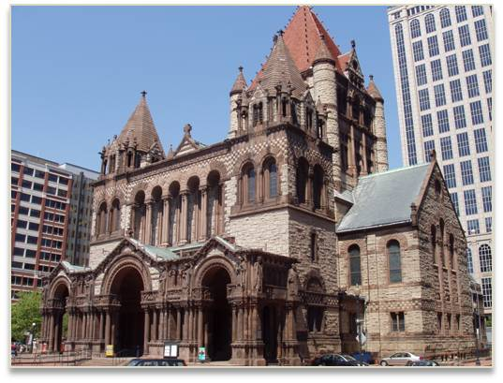
There were several alterations in the original plan. Because of the uncertain support of the made land, the central tower was lowered, and rendered less massive looking by the open filigree work under the red tile roof. The western porch, which Richardson envisioned but never completed, was added after his death in 1897 by his successor firm Shepley Rutan and Coolidge. It is inspired by St. Trophime in Arles, France
(which Richardson greatly admired). The original west facade towers were also replaced at this time.

The building’s massiveness required the strength of granite, so the primary stone is a light Dedham granite, with granite from Quincy, Rockport, Westerly, RI, and Maine, and some of the stone from the burned church for parts of the foundation. Longmeadow sandstone is used for the trim and cut stonework, as well as for the checkerboards and chevrons.
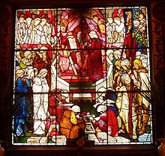
When planning the interior, Richardson worked closely with a group of superb sculptors, painters, and glaziers who contributed richly to the church.
- The biologically correct foliate ornament on the church itself (not on the porch) was carved by John Evans.
- The murals are by John La Farge and constitute the first major mural commission executed by an American artist. (Augustus Saint-Gaudens was an apprentice on the mural project.)
- Trinity’s display of stained glass spans the history of stained glass techniques. Many of the stained glass windows are by La Farge, his most famous being “Christ in the Act of Blessing” situated over the entrance. It is famous for its large expanses of brilliant blue glass, made up of innumerable small roundels, each in its own leaded casing.
- Other windows are by American and English artists. Of particular note are those in the north transept, designed in England by Edward Burne-Jones and executed by William Morris, both of whom were active in the Pre-Raphaelite movement of English artists.
- Charles D. Maginnes designed the present chancel, which was dedicated December 18, 1938.

I urge you to go into the church and spend some time looking at its beautiful interior, particularly John La Farge’s blue window over the entrance.

Trinity’s overall design responds well to its triangular lot, especially by the positioning of the cloisters and Parish House. The Parish House (initially the Chapel) on the north side houses a library, meeting and function rooms, and a few offices. The cloisters form the other three sides.

Phillips Brooks’ presence still resounds throughout the church. He is sculpted on the west porch in the company of the great leaders of Judeo-Christian history; the pulpit depicts him with the great preachers of the world, the baptistery contains a bust of Brooks by Daniel Chester French, and the chancel holds an Ernest Pellegrini bronze relief of Brooks telling little children about the birth of Christ—a reminder that he authored the Christmas carol “O Little Town of Bethlehem.” His bronze statue on the Boylston Street side of the church, designed by Augustus Saint-Gaudens, was unveiled in 1910. (McKim, Mead and White created the baldachino.) The inscription reads:

Preacher of the Word of God •
Lover of mankind •
Born in Boston •
Died in Boston.

Let’s walk down to the next corner and look at another public building with a very different design.

- BOSTON PUBLIC LIBRARY: Stand on Southwest Corner of Copley Square

Boston Public Library Dartmouth & Boylston Streets
- McKim, Mead and White 1888–95 (7 years)
- Addition: Philip Johnson 1971–72 (2 years)
- McKim Restoration: Shepley Bulfinch Richardson and Abbott 1991–201-(?)

The Boston Public Library (BPL) is the oldest free, large, municipal, circulating library in America. The enabling legislation passed in 1848 and it was ready to do business in its first location in 1852. By 1878, the Library had already outgrown its first two locations downtown. The Commonwealth granted land in Copley Square to the Library in 1880. The Library Trustees engaged the New York firm of McKim, Mead and White to “create for the first time in the world a huge metropolitan library for the general public as well as for the scholar.” (Shand-Tucci)

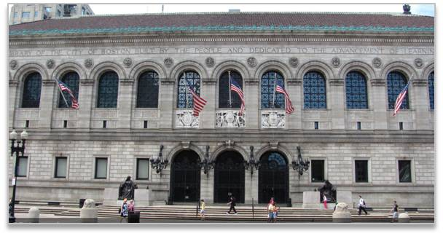
Charles McKim faced some complex architectural problems since there was no precedent in the U.S. for a library of this size and character.

The city architect had initially planned a brownstone edifice full of gables, arcades, and towers, like the old Museum of Fine Arts building but the reaction against such a structure paved the way for McKim’s classical Renaissance design of majesty and simplicity.

Charles Follen McKim (1847–1909) attended Harvard for a year before studying in Paris at the École des Beaux-Arts; upon his return he was apprenticed to H.H. Richardson. The BPL’s design was partly inspired by Labrouste’s Bibliothèque Sainte-Geneviève (1838–50) in Paris,
and by Alberti’s Tempio Malatestiano (1450) in Rimini, Italy. This low, classically horizontal form—versus the darker, vertical mass of Trinity—heralded the American Renaissance of the late 1800s.

The building is significant, because it was an early example of a style that would later become popular for decades. McKim chose pale pink granite from Milford, MA for the facade to complement the surrounding community of dark stone, colored stone, and brick. McKim’s plan was not liked by everyone. When the model went on exhibition, some thought the design recalled a warehouse or the city morgue—the “cigar box” appeared too plain. This Renaissance Revival style with its monochromatic facade seemed subdued and contained when compared to the more colorful, irregular, vertical and picturesque shapes of the original Museum of Fine Arts and the nearby churches, but the grandeur and order of McKim’s building demonstrated that it could be a work of art.

Set on a broad granite platform atop 2000 pilings, the library is 225 feet long and 70 feet high. Its heavy lower level supports a smoother upper story of 13 lofty arched windows. Above the three entry arches are the seals of the Commonwealth of Massachusetts, the Library and the City of Boston. A copper chéneau—or ornamented crest—with a design of alternating shells and dolphins, edges a red-tiled roof topped with masts and finials.

Memorial tablets (“the roster of genius”) list an honor roll of writers, artists, scientists, philosophers, statesmen, and soldiers. Note: Initially, the architects had amused themselves by creating a tablet with an acrostic of their names, where the first letter of each of the listed names vertically spelled out McKim, Mead and White. The Trustees felt the matter was harmless, but the press created such a heated controversy that the offending tablet was removed.

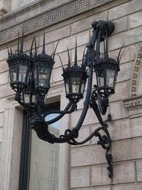
McKim also designed the elegant sweeping Italianate lanterns, which served for many years as the BPL logo. The building surrounds an open-air courtyard, which was inspired by the arcade of the Palazzo della Cancelleria in Rome.

The BPL is embellished with fine works of decorative art in the tradition begun by Richardson for Trinity Church. McKim and Dr. Oliver Wendell Holmes called it “a palace for the people.”
- Sculptor Bela Pratt’s two figures representing Art and Science at the main entrance grace the platform upon which the Library stands.
- Daniel Chester French cast the bronze doors of the vestibule.
- The interior is richly endowed with marble, the sculpture of Frederick MacMonnies and Louis Saint-Gaudens
- Murals were painted by Edwin Austin Abbey, Pierre Puvis de Chavannes and John Singer Sargent.

The BPL was the last of the institutions built directly in Copley Square and “demonstrates the kind of public splendor that could be achieved when architects, painters, and sculptors worked in concert.” (Shand-Tucci) It has been dubbed “our first American Pantheon” due to its architectural art.

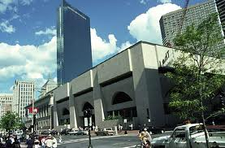
Philip Johnson (1906–2005) was selected to enlarge the BPL. His edifice is composed of 9 square bays defined by 16 square towers. It houses the general library with open stacks, thus preserving the McKim building as a research library for special collections.

Johnson attempted to unify the two buildings by his choice of size, shape, and surface material. In fact, Johnson reopened the same granite quarries used by McKim. However, the foundations are totally different: the McKim building is supported on some 2,000 wooden pilings, while Johnson’s building rests on a 7-foot-thick concrete mat.

Let’s move to the next corner and take a look at this imposing church.

- (NEW) OLD SOUTH CHURCH:
Stand on northwest corner of Boylston & Dartmouth Streets

New Old South Church: Boylston & Dartmouth Streets
- Charles Cummings & Willard Sears 1874–75 (1 – 2 years)
- Restoration: Goody, Clancy & Associates 2001

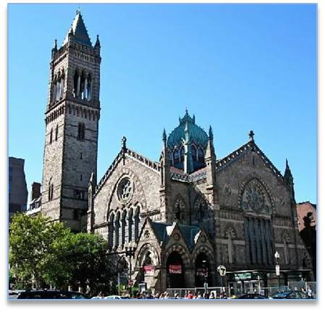
The “New” Old South Church was designed by Charles A. Cummings and Willard T. Sears. The Third Church, which was Congregational, had occupied the Old South Meeting House on Milk and Washington Streets. In 1875, the Society, having sold their historic Revolutionary site, moved into their new Back Bay building.

The design of the church is based on the Northern Italian Gothic, also known as Ruskinian Gothic. John Ruskin, an English architectural critic, had a preference for Italian Gothic, which became very popular by the 1870s in America. Gothic elements of New Old South include:
- The striking campanile,
- Pointed arches,
- Rose windows and a
- Rich assortment of polychromic building materials.

The primary material is Roxbury puddingstone (a conglomerate of loose gravel fused together into a solid mass), with trimmings of brown Connecticut and light Ohio freestone that create colorful voussoirs, and Norman nailhead and zigzag moldings.

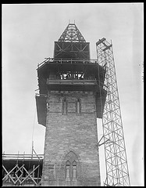
The original tower began to tilt almost immediately (to the southwest) until it was three feet out of plumb. The “leaning tower of Boston” became a bit of a tourist attraction, and was taken down in 1931. The stones were numbered and stored until 1940, when the tower was rebuilt with a steel infrastructure, but lower than before. The top of the tower is pierced by lancet windows of carved mullions and delicate tracery.

The configuration is “a centralized plan in a Gothic envelope.” It has a wide crossing, shallow transepts and apse, and no side aisles. The building is surmounted by a lantern, and topped by a copper roof and iron roof crestings. The grapevine and animal carving (foliate string course) allegedly created by an unknown Scottish stone carver, is best viewed on the Dartmouth
Street side. That motif also appears inside.

The interior boasts Italian cherry woodwork, Venetian-style mosaics and 15th-century English-style stained glass by Clayton and Bell of London. The sanctuary screen behind the choir replicates a design from the Doge’s Palace in Venice. The interior was renovated in 1985 by Shepley Bulfinch Richardson and Abbott. The lantern’s interior depicts a dark blue sky with golden stars.
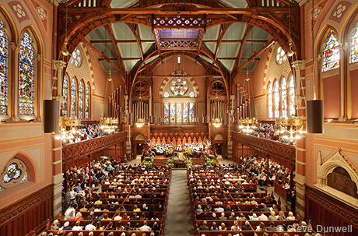
The facade forms a streetscape—it anchors a string of puddingstone buildings lined up along Boylston: the church itself, an entry marked by the tower, a chapel, communal rooms and the parish house. The attenuated porte-cochère adds visual interest. The church does not speak specifically of the architects themselves, but rather to the glory of Gothic Revival. (The faces that adorn the arches of the Boylston Street portico are said to be of Cummings and Sears.)

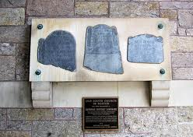
The portico holds pieces of three gravestones, two of which were uncovered in Old South’s tower in 1850. The stones are those of Church founders Joshua Scottow and John Alden, as well as a niece of a founder, Ann Quinsey

Note: Although this building is often referred to as “New” Old South Church, it is called Old South Church in directory listings and in the congregation’s more recent informational material.

Now we’re going to walk to the next corner and look at two buildings that stand across the street from one another as well as on opposite sides of a design philosophy.

- CORNER of DARTMOUTH and NEWBURY STREETS: Stand at the corner

Boston Art Club 150 Newbury Street at Dartmouth Street
- William Ralph Emerson 1881

The Boston Art Club was organized to promote art through exhibitions.

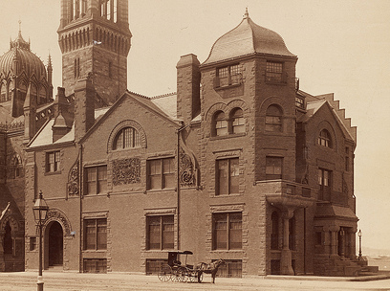
This edifice is in the Queen Anne style, which is closer to an architectural philosophy than an actual style. It was established by English architects who believed that the level of craftsmanship in the building trades had declined as a result of industrialization.

They sought to revive the tradition of craftsmanship they believed had existed through the reign of Queen Anne (1702–14) by designing basically medieval structures with profuse decoration. Many were followers of Barry and Pugin, (designers of the Houses of Parliament)—but the Queen Anne motifs could be blended with other styles as well.

The architect, William Ralph Emerson, nephew of poet Ralph Waldo Emerson, was best known as a country house designer. He was an influential proponent of the Queen Anne style and the shingle style of architecture.

In addition to elaborate decoration inside and out, the Queen Anne style is characterized by an atmosphere of informal comfort: cozy, casual, lacking in symmetrical formality, with large windows and numerous tall chimneystacks suggesting the warmth and hospitality within. Typical also is the use of windows with 9 or 12 small panes in the upper sash over a large single pane in the lower sash.

Here, the ornamentation is executed in hand-sculpted clay blocks as large and high in relief as possible without warping or twisting in firing. The scroll brackets are hand-carved to a depth of several inches—dramatically visible when hit directly by sunlight. In 1884, the Boston Bicycle Club built an addition to the right of the Art Club, making the edifice more square and symmetrical than Emerson initially intended. The two buildings now function as one, and were home to Copley High School for many years.

Hotel Victoria 271 Dartmouth Street at Newbury Street
John Lyman Faxon 1886

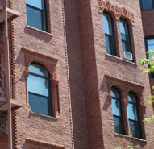
This Moorish-inspired edifice’s most distinctive features are the intricate molded commercial (machine-made) terra cotta around the windows, and the crenellated, stepped parapet and corner battlement. Its mass-produced, uniform design contrasts sharply with the handcrafted quality of the Boston Art Club.

On the Dartmouth Street facade, “Hotel Victoria” in terra cotta is visible above the entry, and the architect’s initials (JLF) are incorporated into the circle elements above the first floor windows in the far right bay. It is now condominiums, and the street level has been modified by retail space.

Let’s move look at a house designed by and for the architect on the opposite corner.

277 Dartmouth Street J. Pickering Putnam 1878

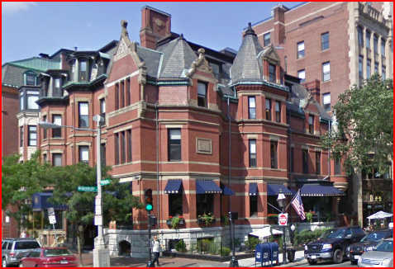
Architect Pickering Putnam built this house inspired by medieval architecture for himself. It was constructed before either the Art Club or the Hotel Victoria.

Described as “piled up, picturesque and polychromatic,” it even boasts a bartizan—a small overhanging turret or tower—on the Newbury Street side.

Putnam was a leading apartment designer, best known for his 11-story Haddon Hall (1894), the scale of which led to height restrictions in Back Bay.

- COMMONWEALTH AVENUE and VICINITY: Stand

Though Arthur Gilman designed the actual plan of the Back Bay, the Commissioners of Public Lands who hired him had several clear goals for the area.

First of all, it was to be spacious, with broad avenues and a uniform setback from the street beyond which no part of the building could extend. About 43% of the state’s holdings went for streets and parks, indicating the extent to which the Commissioners sacrificed short-term profits to ensure the area’s long-term desirability. Indeed, 26 acres of mud flats were allocated to create the Public Garden in 1837—America’s oldest public botanical garden with a 3-acre lake.

Secondly, the area should be homogenous. To this end the Commissioners wrote specific restrictions into the deeds of the land when it was sold, prohibiting commercial, mechanical, and manufacturing uses and stipulating that the edifices should be of a minimum height, constructed of masonry, and could not project beyond the standard building line.

Note: The original Back Bay palette was a low-contrast scheme to celebrate the materials and their intrinsic beauty. Trim, shutters, etc., were painted brown to match brownstone, or in reddish tones to complement brick buildings.

Thirdly, the neighborhood was planned as an ornament to the city. To promote this, the Commissioners actively encouraged the settlement here of many churches and public institutions, as well as clubs, societies, libraries and academia. The proximity of these institutions and the people who supported them made Back Bay the cultural heart of Boston during the Victorian Age.

Overall, the plan and the resulting area have been very successful, and much of it has been saved. In 1966, the General Court passed an act creating the Back Bay Architectural District and the Back Bay Architectural Commission. Back Bay became a National Historic District in 1973. Exteriors cannot be altered without approval from the Back Bay Architectural Commission.

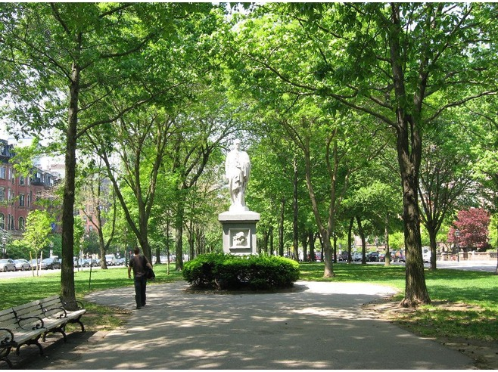
Commonwealth Avenue, with its center strip of parkland, was designed to be spacious. In 1856, the state agreed to make Commonwealth Avenue 200 feet wide. This width was further augmented by a uniform setback of 20 feet from the street on each side. Mercantile use was prohibited.

The nearly mile-long Mall that bisects Commonwealth Avenue is the grand boulevard of the Back Bay—it averages 100 feet wide, covers 32 acres and is dotted with statues and benches. The Mall down the Avenue is part of a series of Boston parks and green spaces. It links the Common and the Public Garden to the six parks laid out by Frederick Law Olmsted in 1880 (from the Back Bay Fens to Franklin Park), known as the “Emerald Necklace.”

In Spring: The first large-scale planting of magnolia trees on Commonwealth Avenue dates from 1963. Their April blooming is now a Boston signal of spring. It has often been said that the area was designed to imitate the grand boulevards of Paris. In 1885, Arthur Gilman “had just returned from Europe, having spent several months in both London and in Paris. During that time, the French capital was being rebuilt by Napoleon III’s préfect of the Seine, Baron Georges-Eugène Haussmann, and this Second Empire Paris it thought to have provided the inspiration for Gilman’s Back Bay design.

In fact, however, Gilman arrived in Paris in the spring of 1853, when massive demolitions were well underway, but far too early to witness the splendors of Haussmann’s grand boulevards. He would have seen some of the earlier improvements such as Louis XV’s Champs-Élysées or the 1850 rue de Rivoli, But in England, he must have viewed some of London’s new urban developments, like Westbourne Terrace, which rose in Hyde Park between 1850 and 1855. Indeed, the view of this district seems as likely a model for Gilman’s Back Bay as any Parisian boulevard.” (Moore & Weesner)

The Vendome: Stand on the Mall at the corner of Dartmouth

160–170 Commonwealth Ave. at Dartmouth St.
- William G. Preston 1871–72
- Addition: J.F. Ober 1881
- Conversion to residences: Stahl/Bennett 1971–75
(100 years later)

The Hotel Vendome was the first large commercial edifice to be constructed in the Back Bay. Because Dartmouth Street was initially designed to be the wide cross-axis to Commonwealth Avenue that would lead into the fashionable South End, the original entrance to the hotel, with its central projecting pavilion, faced onto Dartmouth Street. However, 10 years later, when the addition was built, it had become apparent that the South End was declining and so the hotel was reoriented to face Commonwealth Avenue.

Preston designed a fanciful interpretation of the French Second Empire. His marble building at the corner is covered with machine-incised Neo-Greco ornament, exactly the kind that Queen
Anne practitioners were arguing against. When built, the hotel boasted many luxuries: private bathrooms, fireplaces, and steam heat for each room. Once it was the grandest hostelry in the Back Bay and some of the Vendome’s famous guests included P.T. Barnum, Sarah Bernhardt, John D. Rockefeller, John Singer Sargent and four U.S. Presidents: Ulysses S. Grant, Benjamin Harrison, Grover Cleveland and William McKinley.

America’s first commercial installation of electric lights occurred here in 1882, a reminder that the creation of Back Bay coincided with many technological improvements in private dwellings, such as running water, full indoor baths, central heating, and eventually elevators. These additions to the comfort and efficiency of urban living were matched by a related development and organization of city services, including piping in of water, sewers, garbage removal, snowplowing, and food and fuel delivery.

There were no stores planned for this area; instead, food and fuel were delivered by carts driven down public alleys behind the houses. (The nearest public markets were on Washington Street, about a mile away, until 1887 when S.S. Pierce opened on Dartmouth Street near today’s Copley Place.) These days, the service alleys behind the townhouses are used for dumpsters and parking. There were virtually no stables in the inner alleys; the conditions of sales required consent of all abutters. Horses deposit 7 to 10 gallons of urine and 20 to 37 pounds of manure a day, which create smells and draw flies.

The water side of Beacon Street did have some private stables. Commercial ones emerged south of Boylston Street, and between Hereford Street and Massachusetts Avenue, mainly on Newbury Street.

The most widely used roof of the Back Bay is the mansard roof—a continuous broken roof with a steep lower slope, usually containing dormer windows, and a flatter, shorter upper portion. It is named for François Mansart, a 17th-century French architect.

- AMES–WEBSTER HOUSE: Stand on Dartmouth Street in front of the elevator

306 Dartmouth Street 1872
- Original (only exterior walls and roof at corner remain) Peabody & Stearns 1872
- Remodeling/2 additions: John Hubbard Sturgis 1882
(10 years later)
- Renovation: CBT/Childs Bertman Tseckares & Casendino 1969–71
(Completed almost 100 years later)

This free-standing mansion of 26,000 square feet, 50 rooms, 10 bedrooms and 28 fireplaces dates to 1872. It contains the most palatial room in the Back Bay. The Ames-Webster House was designed in the French Academic style but is a “hybrid” that combines elements from various periods, from a French mansard roof to the English use of multiple materials—brick, stone, wood and terra cotta.

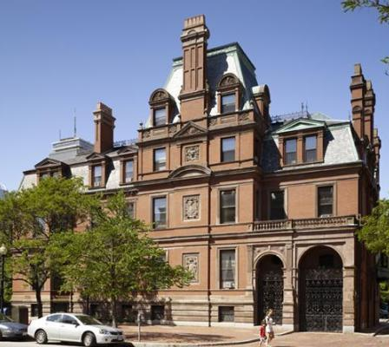
When facing the main entry on Dartmouth Street, the original part is on the left. Ten years later, Sturgis more than doubled the size by adding the conservatory on the Commonwealth Avenue side, the 4-story tower with mansard roof and ornamental chimney in the center, and the porte-cochère on the right. (The porte-cochere is not curved like that of Old South Church. Rather, the carriage was driven straight through and out the back into the alley.)

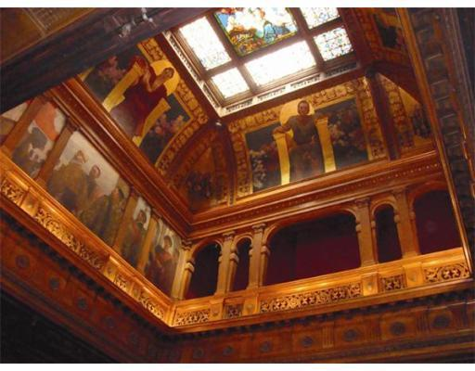
Sturgis totally renovated the interior, creating a great hall for grand-scale entertaining, with 18-foot ceilings and richly carved oak woodwork. The stairwell rises 3 stories and has a cloister-domed ceiling with murals by the French painter Benjamin Constant. Only one of the original John La Farge stained glass windows remains; the rest are housed in museums. Guests would arrive by coach and alight in the porte-cochère, ride the elevator to the second floor where their wraps would be taken, and then descend the staircase when announced by the butler from the landing.

The Ames family enlarged the house soon after buying it in 1882. The Ames fortune was made in shovels—chiefly during America’s move West, the California Gold Rush, and the construction of the
transcontinental railroads and Civil War fortifications. It was later owned by Edwin Webster, a founder of Stone & Webster Engineering (1889–2000).

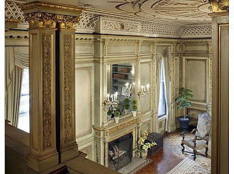
CBT/Childs converted the house to offices without damaging the original character of the rooms, thus earning the First Annual Conservation Award of the New England Chapter of the Victorian Society in America in 1972. It was sold in 2012 for $14 million.

- CROWNINSHIELD HOUSE:Stand on Marlborough Street

164 Marlborough Street at Dartmouth Street
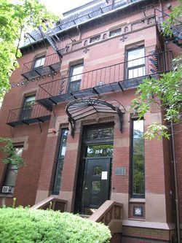
- H.H. Richardson 1869–70

The first of Richardson’s Boston buildings, and only his fourth commission, this house (built for college friend Benjamin Crowninshield) is the earliest example of Richardson’s private residence work still surviving. It not typical of his Romanesque style and shows an interest in intricate brickwork that is similar to the Panel Brick style. A brick box bay marks the entry. At the second story the bay corners twist and spiral, and are topped with seemingly incomplete capitals that are plain on the front and carved on one side.

The carved stairway ends in large corner posts with diagonally patterned brickwork in the baluster wall. Instead of a string course, a line of diamond-shaped ceramic tiles is used and repeated under the eaves, perhaps a device to enliven a north-facing facade that is nearly always in shadow. The same tile pattern is used in the two buildings at 312 and 314 Dartmouth Street, making them appear part of the Crowninshield House.

Note: An attempt to achieve polychromy less expensively by tarring some of the bricks black after they had been laid.

Note: The lobby still contains a staircase with the crown in shield pattern. As of this writing, the house is leased to area colleges as extra dormitory space.

This point on the tour offers an opportunity to talk about the evolution of styles during the development of the Back Bay from east to west, with the French Academic style having been popular in the 1860s and found in the Arlington Street area, followed by the more eclectic stylistic variations in the tour area popular from the 1870s through the mid-1880s, and finally with the BPL being an example of one of the later revival styles.

Cushing Endicott House 163–165 Marlborough Street Snell & Gregerson 1871

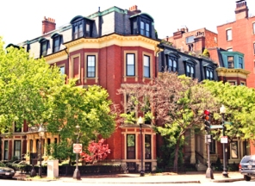
This corner house formed an original, harmonious composition with 326–328 Dartmouth Street. These are 3 separate houses designed as a well-proportioned whole; each house is differentiated by careful adjustment in floor level and cornice line.

Made of brick with Nova Scotia sandstone, it is a good example of the French Academic style, a conservative style of the time. Note the tall, narrow windows, unadorned facade, and the decoration focused around the windows and doorway with keystones, brackets and columns.

The house was built for Thomas Forbes Cushing, whose success in the China Trade is evidenced by the ebony woodwork interior. In 1897, it was purchased by William Crowninshield
Endicott, who served as secretary of War under President Cleveland in the late 1880s and continued to be occupied by the Endicott family until 1958. Nicholas Abraham & Co. restored it in 1985. The 2013 asking price is $7,200,000 or $23,000 a month to rent.

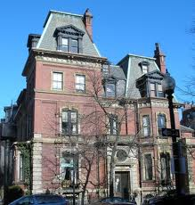
Hollis Hunnewell House 315 Dartmouth Street Sturgis & Brigham 1869

The Hollis H. Hunnewell House was built in 1869 – 1870 and designed by Sturgis and Brigham for Hollis Horatio Hunnewell, son of a wealthy financier, horticulturist and major benefactor for the town and college of Wellesley.

Sturgis and Brigham designed the house with some of Boston’s earliest exterior ceramic ornamentation and used white glazed tiles—seen from the alley—to reflect light into the house.

The mansard roofs atop the irregularly sized towers, and a new one-story wing, were added after a fire in 1881. It has 10,495 square feet, nine bedrooms and six & a half baths. In the early 20th century, the mansion was owned by T. Jefferson Coolidge, great-grandson of Thomas Jefferson, President of the Atchison, Topeka & Santa Fe railroad, and U.S. Minister to France.

8) COMMONWEALTH AVENUE MALL

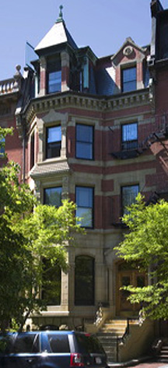
165 Commonwealth Avenue Attributed to Cummings & Sears 1879

This richly carved Ruskinian Gothic edifice has a striking silhouette.
Panels of colored tile and courses of masonry in contrasting colors shows that Cummings agreed with Ruskin that polychromatic effects can be used in place of geometric forms when space is limited. The façade is enhanced with stone carvings that that simulate various textures and Gothic patterns.

It achieves a striking silhouette by carrying the bay window through the cornice into the attic, giving the projection a roof that is separate from the mansard behind it. This destroys the geometric unity of the block but allows the house to stand out with bold impudence.

It was converted to apartments in 1941 and to condominiums in 1977. Condos sell for well over $2 million.

Monuments
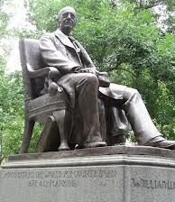
Statue: William Lloyd Garrison Commonwealth Avenue Mall across from Vendome
By Olin Levi Warner 1886
Garrison was one of America’s leading abolitionists and editor of the antislavery newspaper The Liberator.

Vendome Memorial Commonwealth Ave. Mall at Dartmouth St.
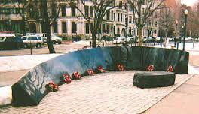
Ted Clausen & Peter White 1997
This granite monument stands across from the Vendome and commemorates the 9 firefighters who died in the building’s 1972 fire.
The building was largely empty the afternoon of Saturday June 17, 1972, save for a few people performing renovations. One of the workers discovered that a fire had begun in an enclosed space between the third and fourth floors, and at 2:35pm rang Box 1571. A working fire was called in at 2:44, and subsequent alarms were rung at 2:46, 3:02, and 3:06. A total of 16 engine companies, five ladder companies, two aerial towers, and a heavy rescue company responded.
The fire was brought largely under control by 4:30pm. Several crews, including Boston Fire Department Ladder 13 and Engines 22 and 32, remained on scene performing overhaul and cleanup. At 5:28pm, abruptly and without warning, all five floors of a 40-by-45 foot section at the southeast corner of the building collapsed, burying a ladder truck and 17 firefighters beneath a two-story pile of debris.
The low black granite arc is inscribed with a timeline of the fire and the names and quotes from the 9 firefighters, and is topped by a firefighter’s coat and helmet in bronze.

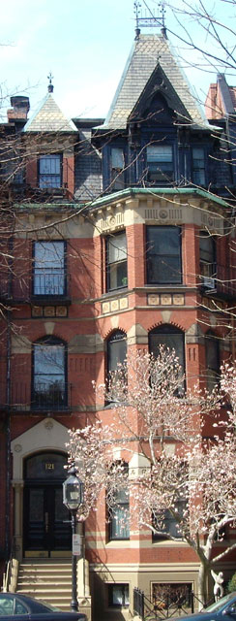
121 Commonwealth Avenue Cummings & Sears 1872

This home was built for Charles Greenleaf Wood, a dry goods merchant and later treasurer of the John Hancock Life Insurance Company.

This is another good example of a Ruskinian Gothic townhouse characterized by abundant decorative and colorful elements, which together make a picturesque ensemble. Two colors of brick, two of slate, stone, wood, ironwork, and polychrome tile are used.

The bay window is treated almost like a tower, with an ornamented peak that projects out from and above the mansard roof.

It was converted to apartments in 1974.

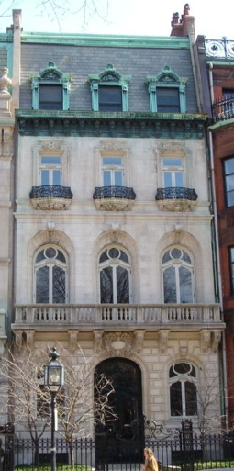
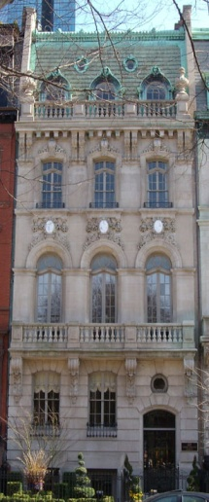
128–130 Commonwealth Avenue “
Samuel D. Kelley 1882; Renovation: Arthur Bowditch? 1905

These two contiguous houses were built of red brick in 1882 and remodeled to limestone in 1905. With French facades, they are designed in a style made popular by the École des Beaux-Arts. They feature balustrades, arched door and window openings, and mansard roofs. In 1908, Charles Bond bought both houses and took down the walls between them so he could have “a large music room in which to entertain.” The walls were restored after his death that same year.

In 1951, they were used academically, and were converted back to residences c.1989.

The interior layout of a Back Bay townhouse didn’t differ significantly from those of Beacon Hill; the upstairs/downstairs arrangement still prevailed. What did change was the level of convenience and comfort due to the myriad technological advances of the time. A typical arrangement could be:
- The ground floor, a few feet below street level for the laundry, furnace, pantry and kitchen.
- The next two floors were for entertaining: the first floor held the dining room and the reception room, and
- The second floor contained the library and the music room or back parlor, which was the realm of the ladies.
- The third floor was for the bedrooms
- The attic was for the servants. (Moore & Weesner)

Purportedly, there was a social geography to the street layout of the Back Bay:
- If you have old family and money, you live on the water side of Beacon Street. (Old rich)
- If you are from old family but don’t have money, you live on Marlborough Street. (Old poor)
- If you have more money than old family connections, you live on Commonwealth Avenue. (New rich)
- If you have neither money nor old family, you live on Newbury Street. (New poor)

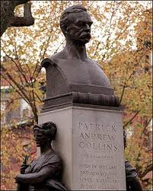
Statue: Patrick A. Collins Commonwealth Ave. Mall at Clarendon St.
By: Henry Kitson & Theo Alice Kitson 1908
Collins was an Irish immigrant who went on to become a lawyer, legislator, Counsel General in London and Mayor of Boston.

Collins (1844–1905) immigrated with his family from Ireland to Chelsea, Mass., in 1848. After working in the trades and being secretary of his union, he entered politics studying at Harvard University. From 1883 to 1889 he served in the U.S. Congress and in 1901 was elected as Mayor of Boston. He served as mayor from 1901 to 1905, when he suddenly died during a visit to Hot Springs, Va.
The two heads on either side of the statue represent his Irish background with one wearing a crown of laurel leaves holding a shield (liberty) and the other wearing a crown of shamrocks holding a harp (Erin or Ireland). The inscription on the sculpture describes how much Collins accomplished in his life as he moved from laborer to mayor.

- FIRST BAPTIST (BRATTLE SQUARE) CHURCH: Stand in front of Rose Window
110 Commonwealth Ave. at Clarendon St.
H.H. Richardson 1871–72

The Brattle Square congregation (which was Unitarian at the time) commissioned Richardson to design a new building in 1870. It became a financial burden and the congregation was dissolved in 1876. The church stood empty for five years until the winter of 1881 when it was purchased by the First Baptist Society, which had been in the South End at that time.

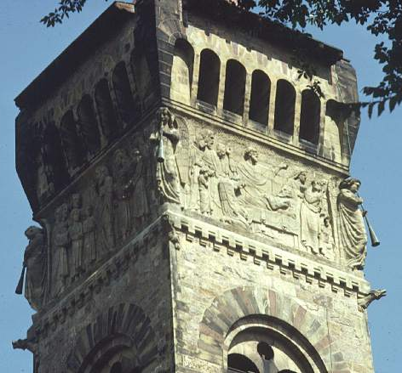
This was Richardson’s first important commission in Boston, and his earliest use of Romanesque elements. The cruciform church is of Roxbury puddingstone with yellow and brown sandstone trim. The 176-foot squared tower rests on four piers connected by great round arches that form a porte-cochère onto an arched entry porch; it is topped by a decorative frieze and corbelled arches. The tower contains a stone from the original Brattle Square edifice that says “John Hancock, Esq. July 27, 1772.” (Hancock was a benefactor of that church, which stood near the site of Boston City Hall from 1772–c.1872.)

The frieze by Frederic Auguste Bartholdi, French sculptor of the Statue of Liberty (1886), was modeled in Paris. Italian workmen carved it after the stones were set in place. It depicts the sacraments: baptism, communion, marriage and death. Many of the faces are said to be likenesses of notable people. Longfellow, Emerson and Hawthorne are represented in the communion frieze, Charles Sumner in the baptism frieze, and Lincoln and Garibaldi in the marriage frieze. The trumpeting angels of judgment gave rise to its nickname, “Church of the Holy Beanblowers.” The trumpets were initially gilded. Note: Charles Follen McKim worked on the Brattle Square Church as a draftsman.

Public Alley 435 Walk down the alley behind the Brattle Square Church

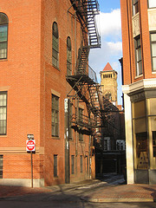
As one enters the alley from Clarendon Street and passes just beyond the Church, on the right is an arched-roof brick addition to the rear of 120 Commonwealth Avenue. Initially a one-story carriage house in 1873, it was converted to a 3-story music room with a barrel vaulted ceiling in 1899.

It is joined to the main house via a white glazed brick connector that reflects light into the music room through stained glass windows. These depict musical composers and motifs (best viewed from the left side of the connector).
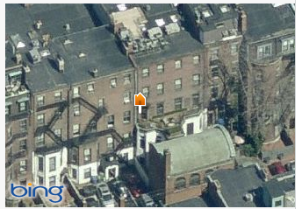
The conversion is visible via the change in brick color on the side of the music room. Today, 120 Commonwealth Avenue is a condominium. Emerson and Fehmer built the main house in 1873 for Laura Case.

Later, Amelia Peabody, daughter of millionaire banker Frank Peabody of Kidder Peabody fame, owned it. After her death, the condo conversion was completed in 1986 with 60% of the interior preserved.

10) TRINITY RECTORY 233 Clarendon Street at Newbury Street: Stand across the street

H.H. Richardson 1879

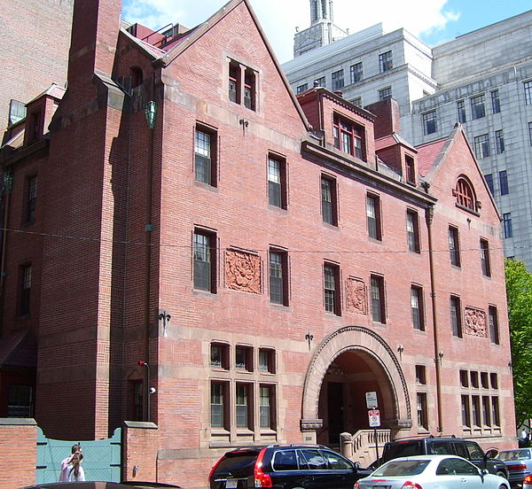
This was initially built for Trinity’s rector, Phillips Brooks, who was a bachelor. He was succeeded by a rector with a large family and it was enlarged in 1893 by adding a third floor. The roof was reconstructed according to its original design. Note the Romanesque entry arch with same flower motif as on Trinity’s apse, the fine brickwork, and the 3 carved brick panels. The larger right gable balances the off-center entrance and smaller left gable, while the second floor windows and cut-brick panels of different sizes help unify the asymmetrical facade. In the original structure, the deeply recessed entrance porch spanned by the broad Syrian arch dominated the façade more effectively than it does today.

In 2007, the Rectory was converted into parish offices. This required ingenuity and sensitivity to provide accessibility, and to position the HVAC system on the roof.

109 Newbury Street by Charles A. Cummings 1871

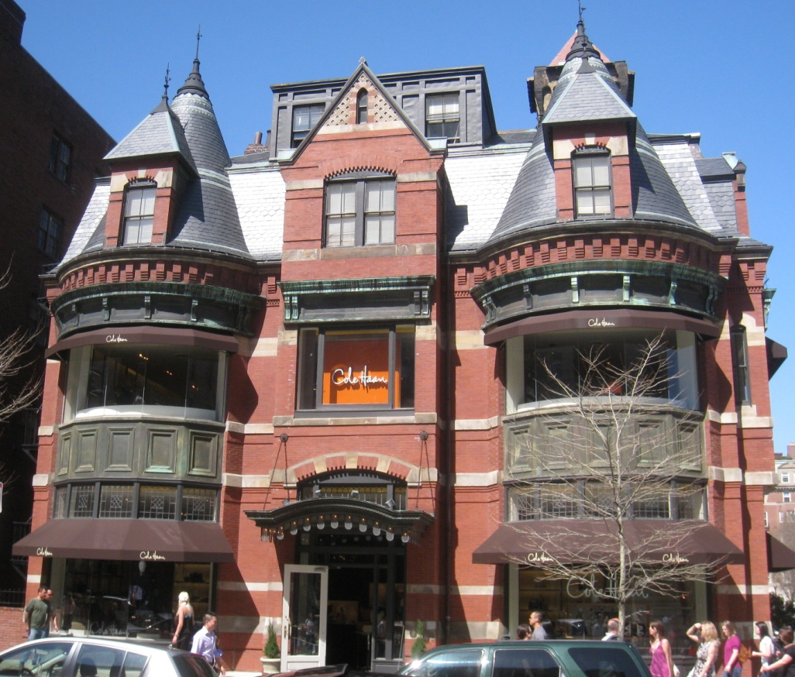
This house was also designed by an architect for his own residence. Charles Cummings of Cummings & Sears built it as his own home

The two donjon towers flanking the central entry and the front door canopy give it a medieval look. Indeed, Shand-Tucci proclaims it “the first full-blooded Medieval house in the Back Bay. As it was built 7 years before Pickering Putnam’s house one block west.

The towers hide the roof; they are not freestanding. The towers, gables, mansard and chimneys mask the fact that this is basically a box with a pyramidal roof on a modest 25-foot lot.

Cummings displayed a preference for contrasting building materials including salmon-colored brick, cream-colored Nova Scotia sandstone, black brick, and three colors of slate. Interestingly, this was built at the opposite end of Newbury’s Clarendon/Dartmouth block from the J. Pickering Putnam house — both have corner lots.

Trinity Cloister Area on Clarendon Street
At the rear entrance of Trinity Church, there is a plaque to H.H. Richardson on the left. Above it is a rosette—part of the Gothic tower from the Summer Street church. When the church burned, Rev. Brooks said that he had never realized how much he loved the old pile until he saw flames running across the roofline and the back of the old high pews.

On the right is a Gothic window tracery from the Church of St. Botolph (Boston Stump) in Boston, Lincolnshire, England—a wonderful Boston-to-Boston link. Boston is actually a corruption of Botolph’s town (or stone).

Continue down Clarendon Street to the John Hancock Tower.

11) JOHN HANCOCK TOWER 200 Clarendon St.

Henry Cobb of I.M. Pei & Partners 1969–75

At 60 stories, 790 feet tall, the John Hancock Tower is Boston’s tallest building, and the third of the John Hancock Mutual Life Insurance Company structures in the vicinity of Copley Square. From the corner of Clarendon Street and St. James Avenue, one can see in the Tower a reflection of the two earlier buildings:
- 197 Clarendon Street: Parker, Thomas & Rice (1922);
- and 200 Berkeley Street: Cram & Ferguson (1947–49).

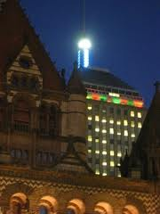
The image of the two older buildings reflected in the glass Tower was long referred to as the “Hancock family portrait.” The 1922 building has been largely “consumed” by the later structures. However, the 1947 edifice is immediately identifiable on the horizon by its truncated stepped pyramid topped by the weather beacon with its poetic key:
Steady blue, clear view;
Flashing blue, clouds due. •
Steady red, rain ahead;
Flashing red, snow instead.
(Or in summer, the Red Sox game is postponed.)
**A steady, combined red and blue means the Red Sox won the World Series.**

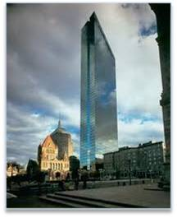
The third Hancock building, known as the John Hancock Tower, was intended by its architect, Henry Cobb, to be a quiet backdrop to its Copley Square neighbors, but it became very controversial. Cobb also wanted the Tower to be shaped as a response to the surroundings. Trinity Church is sculptural and three dimensional. So as not to compete with it, the Tower is flat and two-dimensional. It is clad in reflective gray-tinted glass edged in black aluminum. Richardson’s own favorite and most fully realized view of Trinity was from the apse angle, so Cobb slanted his building away from that view to emphasize the church. The Tower angles away from its street grid, filling out the site only at the lower few floors and creating an entrance plaza that focuses on Trinity with only the thinnest, least overwhelming side presenting to the Square.

The Tower is a landmark visible from Worcester to the west and New Hampshire to the north. Its reflecting qualities are notable: cloudy days color it greenish-gray, while sunny days render the facade a “liquid blue,” which mirrors the sky so perfectly that often the Tower seems nearly invisible. The Tower’s slanted axis stands out from any viewpoint, giving an off-center asymmetrical twist to the grid of Back Bay streets. The vertical indentation in one side gives it a spine. The Tower’s shape is that of a rhomboid, the edges of which appear razor-sharp. Without a top or a bottom, the Tower seems to have slipped up from below through the thin slot of framed metal wrapped around its base.

Four construction problems delayed its completion, resulting in astronomical cost overruns that were finally settled in court in the late 1980s. Excavation caused the first problem: the sides of the hole, though braced with steel, caved in, causing severe movement and settling problems around the site. Cracks appeared in nearby buildings—notably Trinity Church and the Copley Plaza Hotel. Underground utility lines ruptured. The Tower’s foundation is built on 3,000 steel pilings and never moved.

Window breakage presented a second problem. Hundreds of double-pane reflective glass windows blew out and were ultimately replaced by 10,344 500-pound plate-glass windows costing $6,000,000. (As an interim measure, the shattered windows were covered with plywood, giving rise the nickname “The Plywood Palace” or “Plywood Ranch.”)

The third issue was that severe wind sway could have made occupants uncomfortable. It was corrected by tuned mass dampers, an innovation of William LeMessurier for the Citicorp tower in New York City.

Here, the two dampers are 300-ton lead weights installed at opposite ends of the 58th floor, which slide on steel plates covered with a film of oil. Attached to the building’s steel frame by springs and shock absorbers, they counteract the swaying. The fourth problem was the discovery that the building could tilt over along its long axis/narrow end with a certain wind direction. The Tower was stiffened from base to top with 1,500 tons of diagonal steel bracing. National structural engineering standards were also revised before this final problem was solved.

In 2003, John Hancock sold the Tower but as part of the deal, it retains its name. The Hancock Tower stands on the site of Henry C. Cregier’s Hotel Westminster (1897), which boasted ornate terra cotta work and caryatids sculpted by Max Bachman. Ironically, the hotel was required to remove its top floors due to the height restriction of the era. The site now holds Boston’s tallest building.

BUILDINGS / ARCHITECTS / DATES

Trinity Church
H.H. Richardson
1872 – 1877 (5 years)

Boston Public Library
Charles McKim
1888 – 1895 (7 years)
Phillip Johnson
1971 - 1972

Old South Church
Charles Cummings & Willard Sears
1874 – 1875 (1-2 years)

Boston Art Club
William Ralph Emerson
1881

Hotel Victoria
John Lyman Faxon
1886

277 Dartmouth Street
J. Pickering Putnam
1878

The Hotel Vendome
William Preston
1871 – 1872

Ames – Webster House
Peabody & Stearns
1872
John Hubbard Sturgis
1882
CBT/Childs
1969 - 1971

Crowninshield House
H.H. Richardson
1869 – 1870

Cushing Endicott House
Snell & Gregerson
1871

Hollis Hunnewell House
Sturgis & Brigham
1869

165 Commonwealth Avenue
Cummings & Sears
1879

121 Commonwealth Avenue
Cummings & Sears
1872

128 – 130 Commonwealth Avenue
Samuel Kelley
1882
Arthur Bowditch
1905

First Baptist (Brattle Square) Church
H. H. Richardson
1871 – 1872

Trinity Rectory
H. H. Richardson
1879

109 Newbury Street
Charles Cummings
1871

Trinity Cloister
H. H. Richardson
1872 – 1877 (5 years)

John Hancock Tower
I.M. Pei / Henry Cobb
1969 – 1975

APPENDIX — RELATED SITES AND INFORMATION

More information on land making:

The area commonly referred to as Back Bay today extends from Arlington Street to Massachusetts Avenue and from the Charles River to Boylston Street. However, the Back Bay in the 18th century was 737.5 acres of tidal flats with navigable creeks that extended as far west as Kenmore Square and as far south as Washington Street, including part of the South End, part of Bay Village and the Public Garden.

The bay was partially divided by a peninsula, Gravelly Point, in the area of today’s Massachusetts and Commonwealth Avenues. Boston needed mills due to an increase in population and the filling of the Mill Pond. In 1814, an entrepreneur named Uriah Cotting formed the Boston and Roxbury Mill Corporation (B&RMC) and proposed a Mill Dam across the Back Bay to make use of the tides to power mills. Mill Dam went from the corner of Beacon and Charles Streets. A second dam extended to Kenmore Square from Gravelly Point. The east side of the area enclosed by the Mill Dam was the receiving basin (about 500 acres kept dry), and the west side was the full basin, 100 acres.

During high tide water would flow into the full basin, the gates would close, and then the water would pass through raceways in the dam, powering mills as it flowed into the receiving basin, from which it would be released back into the river at low tide. In 1824, the Boston Water Power Company (BWP) was incorporated with the right to purchase the waterpower created by the Mill Dam. In 1832, an agreement was made with the B & RMC whereby the BWP acquired the mills and all the land south of the Mill Dam and the B & RMC retained the roads and the property north of the dam. The 1830s saw the entry of the railroads into Boston. They all built tracks on raised beds, which impeded the flow of water in the receiving basin. By 1840 it was obvious that the mill project was a failure. Some of the receiving basin had been filled, and the remainder was crossed by dikes and railroads. In addition, the receiving basin was becoming a health hazard from the sewage that was discharged into it and the drains that had been obstructed by filling. The city had two options: to keep extending sewer lines towards open water, or to fill in the receiving basin. The commissioners appointed by the city all agreed that filling the basin was the best course of action.

But first ownership of the various parts of the basin had to be established. In an 1853 agreement between the three major owners of the Back Bay, B&RMC was given 200 feet north of Mill Dam (Beacon Street to the Charles River), as far west as Clarendon. In return for giving up claims to land south of the Mill Dam, B&RMC was given 102 acres in the receiving basin, south of Providence Street and east of Exeter, (Boylston south) plus an area bounded by Mill Dam, Cross Dam, and Commonwealth Avenue, in a line between Fairfield and Exeter Streets. In total, B & RMC received 300.1 acres. The state, which received what we think of as the Back Bay today, laid out the area from Arlington to Fairfield in a grid pattern of avenues crossed by streets named in alphabetical order.

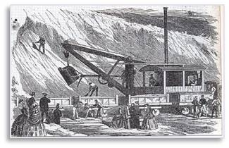

The filling was done by bringing gravel in from the eskers (glacial deposits) in Needham, 9 miles by railroad, first on the New York & Boston track, and then on a track they built along the Riverside MBTA route leading to the site of Back Bay Station today. In the Back Bay, three parallel spurs were laid, 200 to 300 feet apart, and these were moved westward as the land was filled. In Needham, the 35-car train would be separated and pulled by two locomotives down two spurs, each one with a steam shovel that would drop two loads in each car. Then the 35 cars would be reconnected and return to Boston. The filling took about 10 minutes. The cars were dumped 10 at a time from the parallel spurs when they reached Boston, and the gravel was spread by horse-drawn scoops, scrapers and carts. The entire round trip took 45 minutes.

Who did what.
- Boston & Roxbury Mill Corporation: filled north side of Beacon Street to Charles River, Fairfield to Exeter, plus area south of Providence and east of Exeter. (south of Boylston)
- Commonwealth of Massachusetts: Arlington to Fairfield, south side of Beacon to Boylston.
- Boston Water Power Company: Copley Square south and west to Kenmore Square.

There was some concern about the grid of the state-developed part of Back Bay meeting up with different grades and plans of the BWP-developed land. Two new diagonals were put in: Columbus Avenue from Park Square to the South End, and Huntington Avenue from Boylston and Clarendon to Roxbury. As part of the same agreement, BWP was to give a block of Copley Square for the Institute of Fine Arts (site of Copley Plaza today), just as the state had given the block on Clarendon and Berkeley between Newbury Street and Commonwealth Avenue for MIT and the Boston Society of Natural History.

Note: By 1835, two pairs of rail tracks crossed the Back Bay mud, intersecting just south of today’s Copley Square. The Boston & Providence ran southwest to northeast to its Park Square terminal, while the Boston & Worcester (later the Boston & Albany) ran northwest to southeast. These routes left a permanent imprint on the map of Boston, forming a boundary between Back Bay and the South End, and determining the site and shape of such landmarks as Copley Square and the Mass. Turnpike.

Additional information on Copley Square:

The 1966 plan of Sasaki, Dawson, & DeMay lowered the grade of the Square nearly 12 feet below sidewalk level and was mostly paved. In 1983, to address public dissatisfaction with the Square, the Copley Square Centennial Committee was formed, and established criteria for a new park. A national design competition was held in 1989 and in 1991, the current Copley Square Park, designed by Dean Abbott of Clarke & Rapuano, was dedicated. In 1992 the Copley Square Centennial Committee was revamped as the Friends of Copley Square, whose mission is to preserve and enhance the park as a recreational resource.

Fairmont Copley Plaza Hotel 138 St. James Avenue Blackall & Hardenbergh 1910–12
This hotel occupies the site of Sturgis & Brigham’s original Museum of Fine Arts of 1876, purportedly inspired by London’s then new and innovative South Kensington Museum 1852 (now the Victoria and Albert Museum). The hotel is largely the work of Henry Hardenbergh, who also designed the Plaza Hotel and the Dakota Apartments in New York City and the Willard in Washington, D.C. His local associate Clarence Blackall is best known for his theatres. The Renaissance Revival facade is of rusticated limestone. The lions date from 1899, and were inspired by “Wallace” of the Boston Zoo. They once stood in front of The Kensington, a residential hotel that was razed. In 1967, the lions were gilded and moved to Copley Square. (Moore/Weesner)

The Tortoise and the Hare in Copley Square Nancy Schön 1994
This bronze sculpture, which recalls one of Aesop’s fables from 500 B.C., was placed by the Boston Athletic Association at the finish line for the 100th running of the Boston Marathon on April 15, 1996. The lesson that “slow but steady wins the race” is as true for marathoners as for the tortoise, here crossing the finish line ahead of the hare. Schön also created “Make Way for Ducklings” in the Public Garden.

Boston Marathon Monument Copley Square on Boylston Street Mark Flannery 1996
The granite medallion consists of 2 concentric rings around a sculpted center. The rings include the names of all official male and female champions from the open, masters, and wheelchair divisions since the inaugural Marathon in 1897. The outer ring offers space for the names of future winners. At the center are an elevation profile and a planometric of the marathon racecourse. The map’s 8 colors of granite symbolize the diversity of its runners and also represent the 8 cities and towns along the 26.2-mile route from Hopkinton to Boston. A laurel wreath, the traditional symbol of victory, encircles the medallion. The unicorn is a symbol of the Boston Athletic Association (BAA). The granite bollards at the corners of the monument support bronze medallions showing scenes of the marathon and the official crests from the 8 cities/towns. The final touch is a quote from Tennyson’s Ulysses: “One equal temper of heroic hearts, made weak by time and fate, but strong in will to strive, to seek, to find, and not to yield.”

Copley Place 100 Huntington Ave The Architects Collaborative (master plan for entire development) 1980–84
The complex includes 2 hotels, offices, a garage, and a shopping mall. Problems included routing traffic, relating to Copley Square monuments & South End homes, and benefiting nearby neighborhoods. The BRA required color and banding to match existing Copley Square edifices, and the tallest tower to form a spine in line with the Hancock and other high-rises. Here stood E.S. Tobey’s S.S. Pierce Building of 1887.

Trinity Place Huntington Avenue & Blagden Street CBT 1999–2000 This 18-story condominium complex contains luxury residences, restaurant/retail space and a garage.

111 Huntington Avenue CBT 2001
This 36-story building, with its distinctive crown was the first tall office tower constructed in Back Bay since 1991.

Lenox Hotel 710 Boylston Street at Exeter Street Arthur Bowditch 1900–01
Brick with stone trim, and Renaissance Revival detailing: 2-story base with rusticate stone, quoins and pediments.
The New England building 501 Boylston St. Cram & Ferguson 1939-41; Hoyle Doran & Berry 1961
David McCord’s famous clerihew: Ralph Adams Cram — One morning said damn — And designed the urn burial — For a concern actuarial.
Built for New England Mutual—the first mutual life insurance company chartered in America (1835). Designed by Cram’s partners, it allegedly displeased Cram immensely. It stands on the site of William G. Preston’s Rogers Hall (1865), MIT’s first building, named for its founder, William Barton Rogers. MIT moved to Cambridge in 1916 but the school of architecture remained until the late 1930s. This was America’s first architectural school founded in 1865 by William R. Ware. During the 1913 excavations for the present Arlington Street subway station, 65,000 wooden stakes were found 31 feet below street level. They were determined to be part of an ancient fish weir used c.2500 B.C. The Newbury Street lobby holds several dioramas—one showing the weir construction. The Boylston Street lobby contains murals by Charles Hoffbauer of Boston’s early history. Evidence of other fish weir sites was discovered during excavations in 1939, 1949, 1960 and 1986.

500 Boylston Street John Burgee with Philip Johnson 1988
The base of this 25-story office tower rises 6 stories, and wraps around a large courtyard. Shops and restaurants fill the lower levels. The initial plan in 1983 called for 2 identical towers on Boylston Street between Berkeley & Clarendon Streets and was initiated by The New England insurance firm and developer Gerald D. Hines Interests of Texas. Within two years a citizens group was formed in opposition to the design, proximity to Trinity Church, traffic movement, and the effect on local water tables. The outcome was that Phase I – 500 Boylston progressed, but that Phase II – 222 Berkeley Street was given to architect Robert A.M. Stern.

222 Berkeley Street at Boylston Street Robert A.M. Stern Architects 1991
A Boston palette of red brick, granite, and limestone is evident in this mixed-use edifice of offices and shops. The Boylston Street entrance is flanked by Ionic columns holding urns and is entered via a door housed in a tempietto. A gilded dome, reminiscent of the State House, caps the center door. Robert Campbell referred to the building as the Proper Bostonian—“a little too tame for some, but so well-mannered that you can’t be offended.” This was Stern’s first large building after creating many elegant homes. He was also in the awkward position of taking the job from his mentor, Philip Johnson.

Chilton Club 287 Dartmouth Street at 152 Commonwealth Avenue Peabody & Stearns 1870
Founded in 1910 and named after Mary Chilton (traditionally the first woman to set foot in Plymouth off the Mayflower), this was the female counterpart to the Somerset Club. Initially, there were three entrances: one for members, one for guests and an alley entry for servants.

Arthur Hunnewell House 303 Dartmouth Street Shaw & Shaw 1876–77
This is a free Classical rather than an Academic structure. Oriel windows and changes in materials from the stone basement to the brick superstructure suggest simultaneous influence from France and the English Queen Anne style. Contiguous with this is 151 Commonwealth Avenue, designed in 1876–77 by R.G. Shaw, of Shaw & Shaw, as his own home. The Commonwealth School, founded in 1957 as a private day school, grades 9–12, moved here in 1955.

273 Clarendon Street 1869
In 1896, Harriet Hemenway and her cousin Minna Hall began a campaign to save the bird population that was threatened by the use of feathers in women’s hats. Their efforts led to the formation here of the Massachusetts Audubon Society, one of the first environmental groups and the oldest surviving Audubon Society in the country. The house was owned by Henry Adams in the 1870s; he lived and wrote here while teaching at Harvard.

Berkeley Building 420 Boylston Codman & Despradelle 1905; Renov: Notter, Finegold & Alexander 1988 This Beaux-Arts building uses a steel frame to maximize the size of window openings, which are further enhanced by the use of bays. Only slender arches of white-glazed terra cotta break the metal curtain wall. The entire cornice/parapet was recreated using concrete components. New ground floor storefronts were carefully recreated to look like the original. (Longtime Bostonians know this as the Decorators Building as it was the headquarters for many interior design firms, which have since moved to the Design Center in South Boston.)

Gibson House 137 Beacon Street Edward Clarke Cabot 1859–60
Declared a National Historic Landmark in 2001, this brownstone and brick single-family residence, home to three generations of Gibsons, retains its kitchen, scullery, butler’s pantry and water closets, as well as formal rooms and private family quarters, and is filled with the family’s original furniture and personal possessions. It provides an authentic glimpse into daily life in Boston’s Victorian era.

More about Back Bay streets: The street plan of the area was very orderly. Beacon and Boylston Streets were continued west. Newbury and Marlborough in the colonial period had been portions of Washington Street, and the names were revived in the Back Bay. Newbury was the least fashionable street. The first retail shop opened at 73 Newbury Street in 1905. The upper block of Newbury was a remote stable area for Back Bay owners. Marlborough is not a thoroughfare, and so it is the quietest Back Bay street. Aside from two churches, the rest of the street is almost entirely residential.
The waterside of Beacon Street was desirable, as was the sunny side of Commonwealth Avenue. Oliver Wendell Holmes referred to Beacon Street as “the sunny street that holds the sifted few.”

Beacon Street’s alley system along the Charles River and Storrow Drive varied significantly from the rest in the Back Bay since those parcels were owned by the Boston & Roxbury Mill Corporation. They were the only parcels to have stables built directly behind the houses since they were not owed by the Commonwealth, and so were not subject to the same restrictions. Some of these have been converted into or replaced by garages.

Architecturally, there were 3 major stylistic periods exemplified in Back Bay.

1) French Academic (c.1857–69): This used the mansard roof exclusively and was characterized by a sober symmetrical facade of sheer brick with brownstone details, or in some cases, all of brownstone. The entrance was the focal point—a shallow porch or recessed vestibule, with column or pilaster supports. Windows were topped with pediments or keystones, and there was a strong use of balustrades and string courses for structural emphasis.

2) High Victorian period (c.1869–85):
Architects seemed to be looking for novel ideas. The roofline became different, with the plane of the facade broken up by bay windows. A variety of materials were used, i.e. various types of brick and stone, terra cotta, colored slate, polychromatic tiles and iron. These materials appear in Ruskinian Gothic, Richardson Romanesque, Queen Anne and variations of French Academic style. 3) The last period (c.1885–1917): marked a return to more conservative

Revival Styles such as Federal Revival, revival of Greek Revival, and Renaissance Revival (the latter was a style introduced by Charles Follen McKim, widely copied, and broadly interpreted as Classical Revival style).

Townhouse: A multistory urban house, attached or detached, that is built close to the street in rows of similarly scaled buildings.

Rowhouse: A subgroup of townhouses— a multistory urban house usually with narrow street and rear facades, and longer fire-resistant, windowless sidewalls shared with adjoining residences. They tend to be designed in a style that is consistent with, even replicating, that of connecting houses; often built by the same architect and developer.

In Rowhouse construction, it became fashionable in the mid-1800s to face the front facade with brown sandstone. The extensive construction of these “brownstones” led to the widespread adoption of the term to describe any attached or semiattached urban house. (Murphy)

During the period of its greatest use, brownstone was focal to the look and feel of American architecture. In addition to its use in residences, it was found in religious, industrial, commercial, and public buildings. Brownstone use was most common in the Northeast, close to the principal quarries. Unfortunately, its layered composition and high porosity means that brownstone deteriorates easily. It is quite vulnerable to the action of water, salts, freezethaw cycling, and the like; the Northeast climate is particularly hard on the material. Thus, brownstone presents significant maintenance problems for many owners of historic brownstone buildings. (NY Landmarks Conservancy)

Boston Brahmins: Dr. Oliver Wendell Holmes is largely credited with coining the term Boston Brahmin in1860. (In India, a Brahmin is a member of the highest or priestly caste among the Hindus.) The term quickly came to connote families with old New England roots, many having made their fortunes as American merchants. Brahmins frequently intermarried, founded, endowed and patronized institutions of culture, learning, charity and religion, and typically had some connection with Harvard. Brahmins practiced the custom of linking party-giving with alms-giving, creating a city with a reputation for “constant benevolence.”

Among the Boston Brahmin caste, rules of etiquette and decorum were monitored with stern vigilance. It was appropriate for a Brahmin to have one’s name in a newspaper on only three occasions: birth, marriage and death. Brahmin family names included:
- Appleton,
- Codman,
- Coolidge,
- Crowninshield,
- Cushing,
- Endicott,
- Forbes,
- Lodge,
- Peabody,
- Perkins, and
- Saltonstall.

“A Boston Toast” – by John Collins Bossidy, neatly sums up the Brahmin culture:
And this is good old Boston,
The home of the bean and the cod,
Where the Lowells talk only to Cabots,
And the Cabots talk only to God.

“In Boston they ask, how much does he know? In New York, how much is he worth?
In Philadelphia, who were his parents?” —Mark Twain North American Review January 1895

